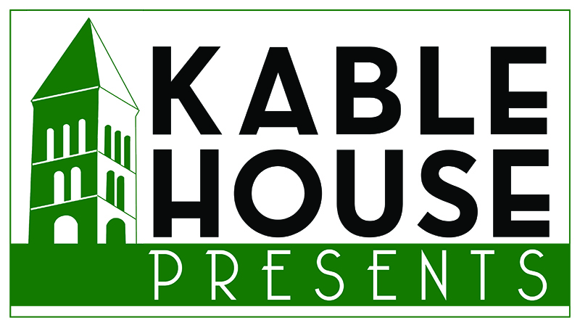
c/o 144 Roosevelt Avenue • York, PA 17401
kablehousepresents@gmail.com • (717) 495-4388 • kablehousepresents.com

Pledge Form

Thank you for supporting Kable House Presents and live music in downtown York.

Donor name (as you would like it to appear in correspondence and donor recognition materials)
_______________________________________________________________________________________
Contact name and title ____________________________________________________________________
Address ________________________________________________________________________________
City ________________________________________________ State _________ Zip _______________
Phone __________________________ Email _________________________________________________
Pledge Amount: $
Please make checks payable to Downtown Inc and write “Kable House Presents” in the memo line, and return to:

Kable House Presents
c/o 144 Roosevelt Avenue
York, PA 17401

Donor / representative signature

__________________________________________________________ Date _______________________

_____ I wish to remain anonymous. Please do not announce my/my company’s name as a donor at events or in publications.

